Nathan Heckman

ARM Assembly Programming Question 6:

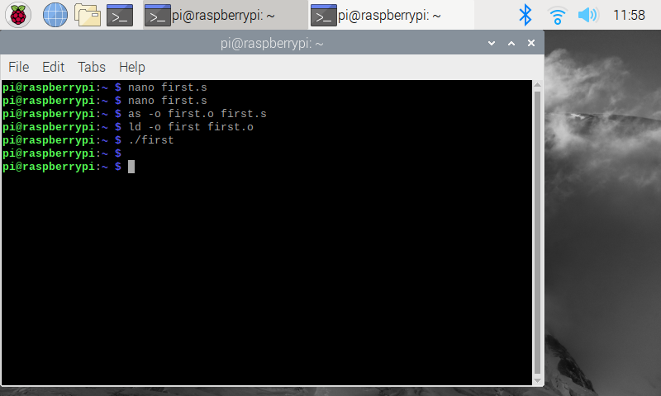

Here I attempt to run the first program using ./first and no output is given. This is because the program isn’t in debug mode and no program stop point is set. The info registers command also hasn’t been written and will therefore produce no output. I then went into debug mode and was able to run the program.

ARM Assembly Programming First Program:

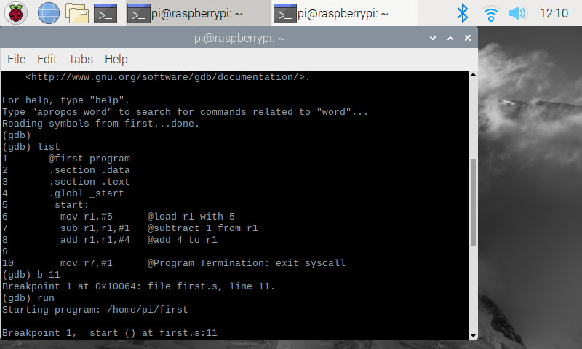

This is the code for the first program which was outlined in the assignment instructions. I used this template to build the arithmetic1.s program.

ARM Assembly Programming First Program Registers:

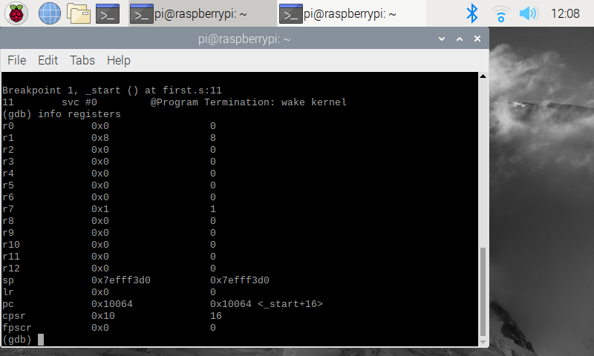

These are the registers after the first program is executed, shown by using the info registers command inside the debugger. R1 holds a value of 8 since 5-1+4 = 8. R7 holds a value of 1 since we assigned it the value at the end of the program.

ARM Assembly Programming Arithmetic1 Code:

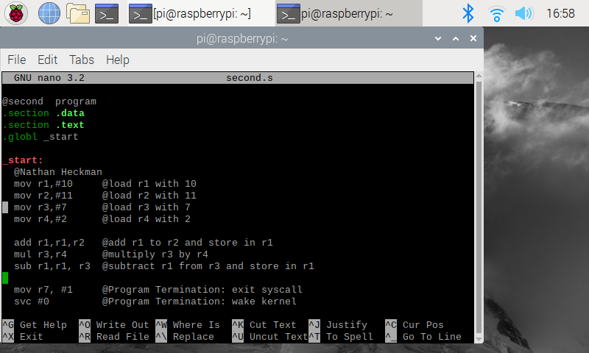

This is the code for the arithmetic1.s program. I followed the same steps as the last program to assemble, link, run, and debug.

ARM Assembly Programming Arithmetic1 Info Registers:

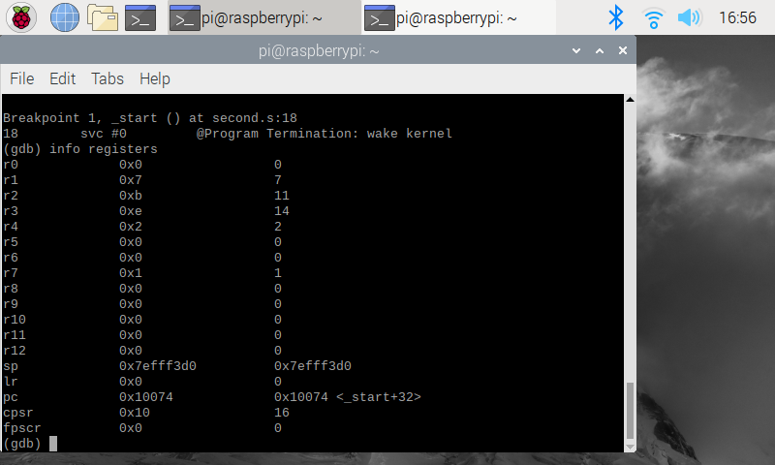

These are the registers after the second program is executed. R1 holds a value of 7 since (10+11) – (7 \* 2) = 7. R2, R3, R4 hold their values because that is the value we assigned to them in order to eventually store the operation in R1. R7 holds a value of 1 since we assigned it the value at the end of the program.